**Assignment 35.2**

**Problem Statement:**

● Explain and perform Sqoop Incremental Import operation to load data from Mysql To HDFS using Sqoop

● Explain the procedures performed, Share the screenshots of commands and results for the same.

To perform Sqoop Incremental Import operation to load data from Mysql To HDFS using Sqoop we need to create a table.

Creating a table named Employee and inserting the values using insert command.

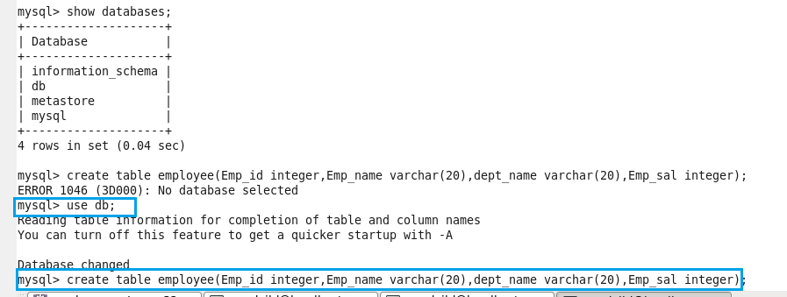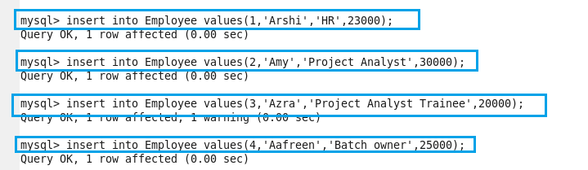

**Performing basic select operation to display the contents of the table**

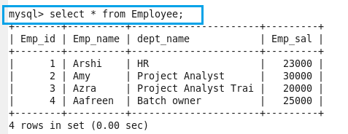

**Importing the data from mysql to hdfs using the below command**

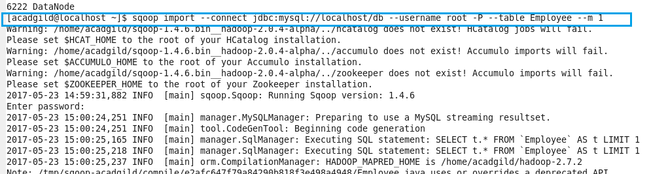

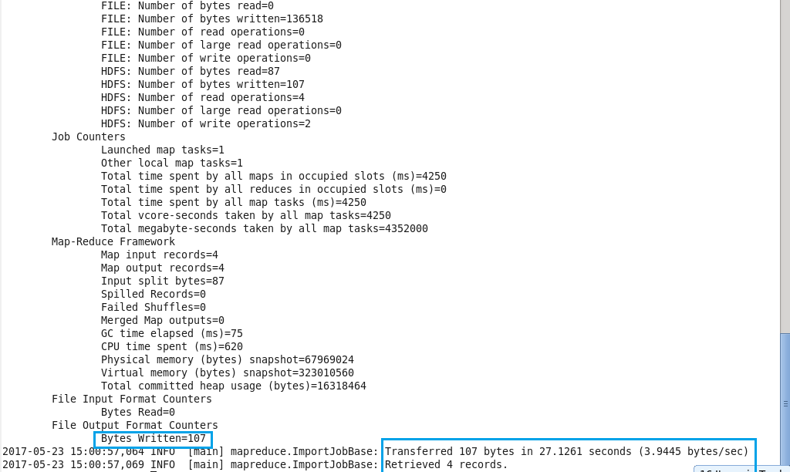

Here we can see that the data is imported successfully to hdfs.

**Checking whether the files are imported and displaying the contents of the Employee:**

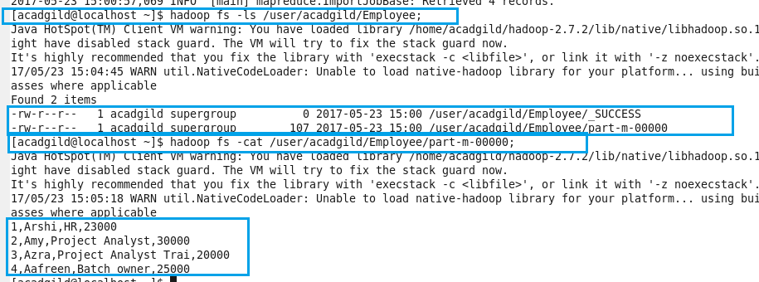

**Inserting 4 more records in the existing table :**

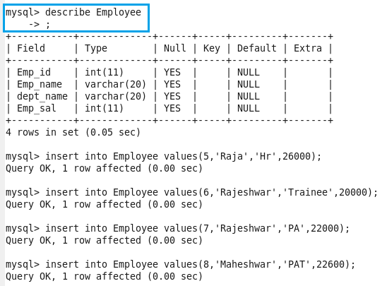

**Displaying all the contents using select command.**

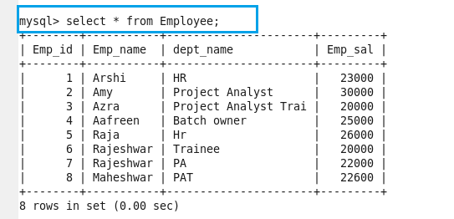

**Performing incremental append using below command:**

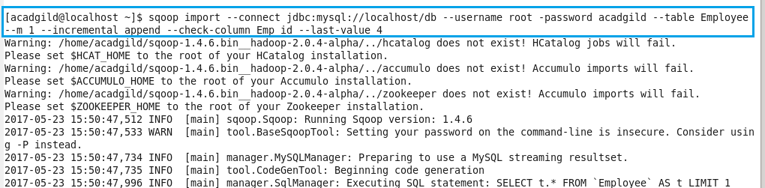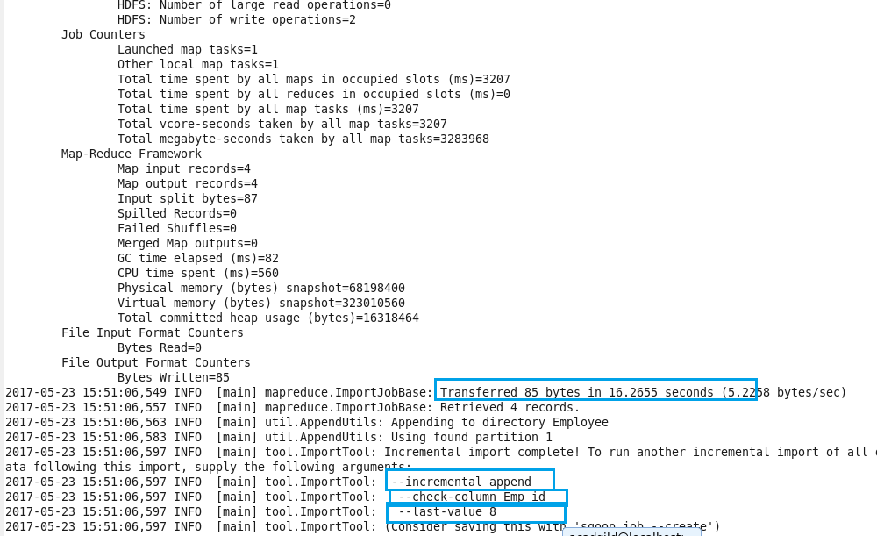

**Imported data is displayed from hdfs:**

